Project Title: | Consultancy Services - LONG TERM (LTA) For Services of Engineering Consultancy Firm Stabilization & Development Program (SDP)
Donor: | PEPAC Consultant
Duration: | September 22, 2021 to September 21, 2023
Working Area: | Merged Districts - Khyber, Kuram, Orakzai, North and South Waziristan of the KP
Beneficiaries: | Rural Communities of the working areas
Budget: | 22,321,000 (PKR)
Project Objectives: | - To improve access to safe water, sanitation and hygiene (WASH) services in schools and health units, promoting a healthy and conducive environment for learning and healthcare delivery.  - Enhance knowledge and behavior change regarding WASH practices among students, staff and healthcare providers, leading to improved hygiene practices and reduced incidences of waterborne diseases.
Key Activities: | - Infrastructure development  - Hygiene promotion and education  - Water quality and sanitation management  - Institutional capacity building

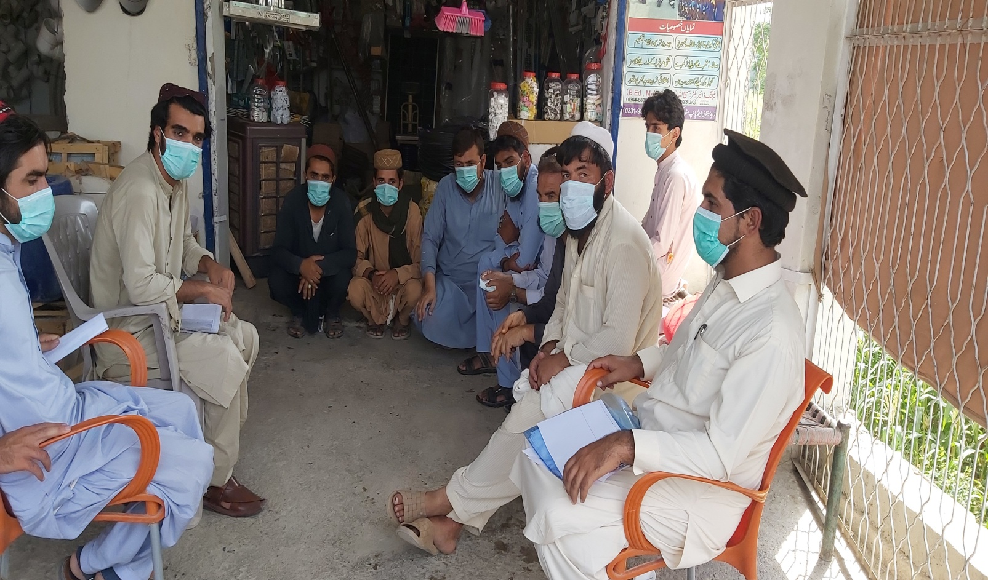 | 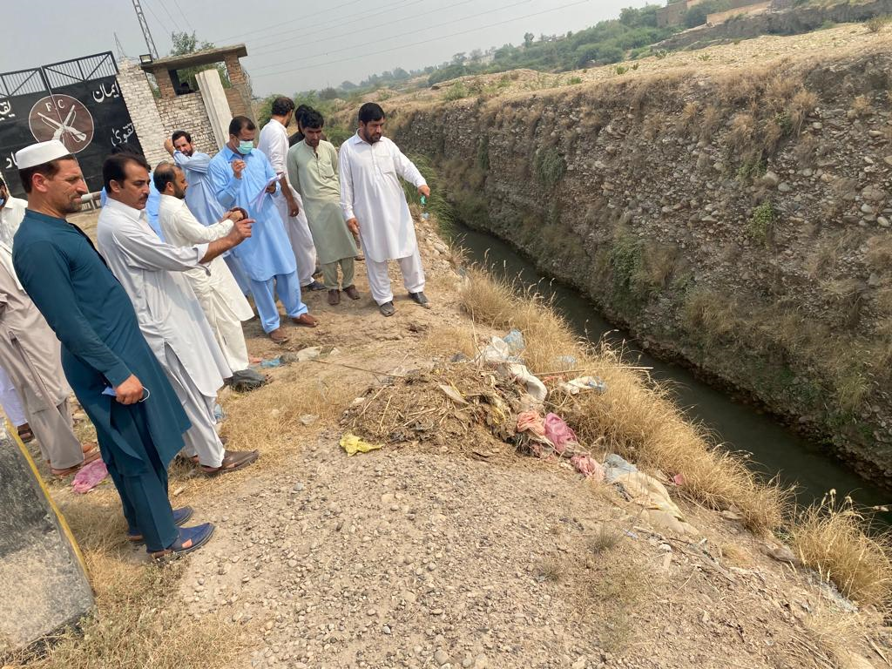
ASSESSMENT ODF WASH FACILITIES IN DISTRICT NORTH WAZIRISTASN VILLAGE EMAKI KALY | ASSESSMENT ODF WASH FACILITIES IN DISTRICT KHYBER BUS STAND

