Project Title: | Distribution of WASH, NFI and Hygiene Kits in COVID-19 affected communities of Mirpur Khas, Sindh
Donor: | Own Fund
Duration: | August to October, 2020
Working Area: | Selected villages of District Mirpur Khas
Beneficiaries: | COVID-19 affected community of the District
Budget: | 1,015,000 (PKR)
Project Objectives: | - To provide awareness on the COVID-19 Pandemic, safety and protective measures and use of Personal Protective Equipment (PPE)  - To support the community members by providing NFI and Hygiene Kits.
Key Activities: | - Coordination with Health Department of Mirpur Khas  - Mass awareness on safety and preventive measures from COVID-19 infection and protocols  - Awareness of the community on importance of hygiene and use of Personal Protective Equipment (PPE)  - Distribution of NFI and Hygiene Kits among the community

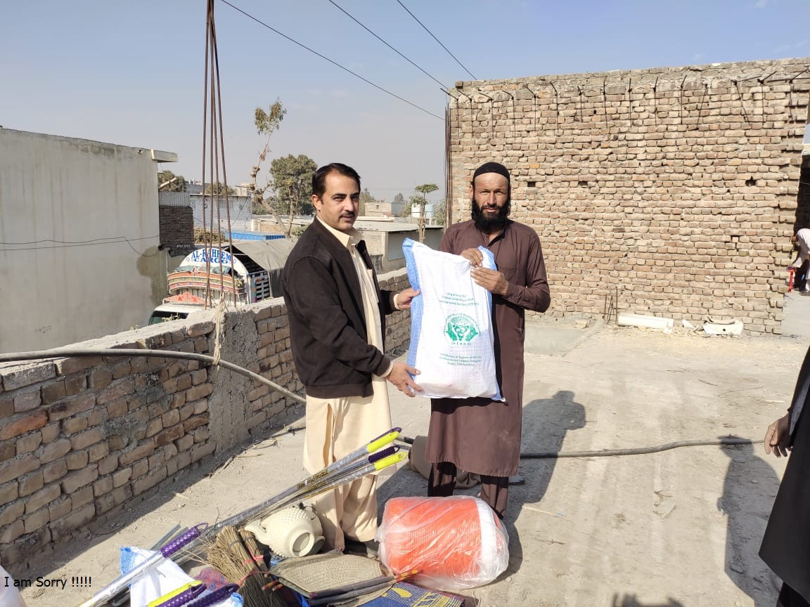 | 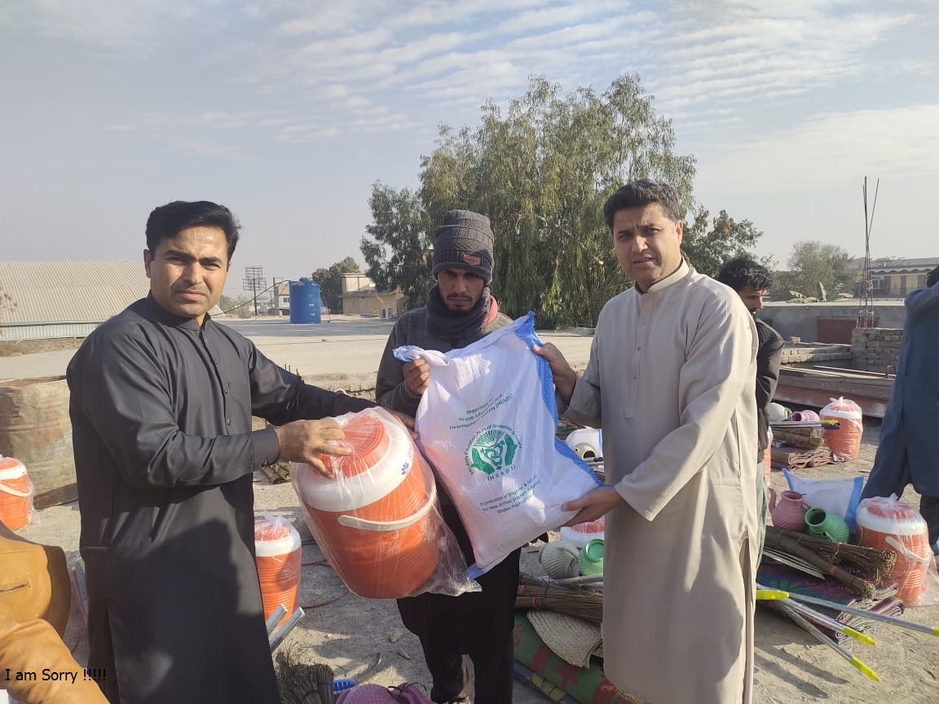
Distribution of WASH, NFI and Hygiene Kits in COVID-19 affected communities of Mirpur Khas, Sindh | Distribution of WASH, NFI and Hygiene Kits in COVID-19 affected communities of Mirpur Khas, Sindh

