Project Title: | Pakistan Flood Response - Disasters Emergency Committee (DEC)
Donor: | International Rescue Committee (IRC)
Duration: | October 2022 to February 2023
Working Area: | Flood affected UCs of District DI Khan
Beneficiaries | Flood affected communities in the selected UCs of District DI Khan
Budget | 9,551,475 (PKR)
Project Objectives: | To organize community, increase crop productivity, improve access to clean drinking water and sanitation facilities, provide health education services, and support child protection
Key Activities | - Establishment of Male and Female Committees  - Health (Conduction of Medical Camps  - Multi-Purpose Cash Assistant (MPCA)  - Establishment of Women and Child Friendly Spaces  - Case Management Cash Support for High-Risk Women & Children  - Provision of WASH services in the affected communities  - Providing WASH infrastructure in the Targeted Health Facilities and Schools  - Economic well-being  - Basic integrated primary health care  - Capacity Building of target communities on DRR, Climate Change and Resilience

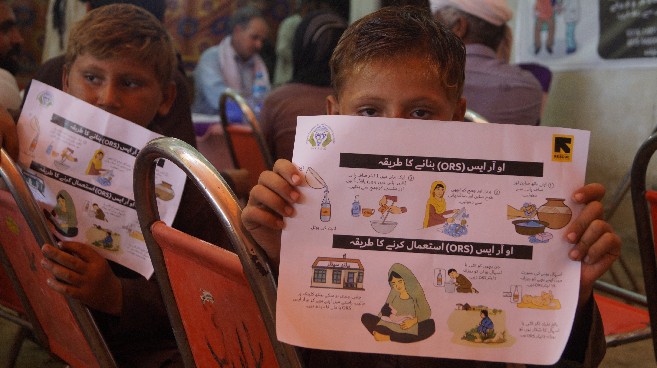 | 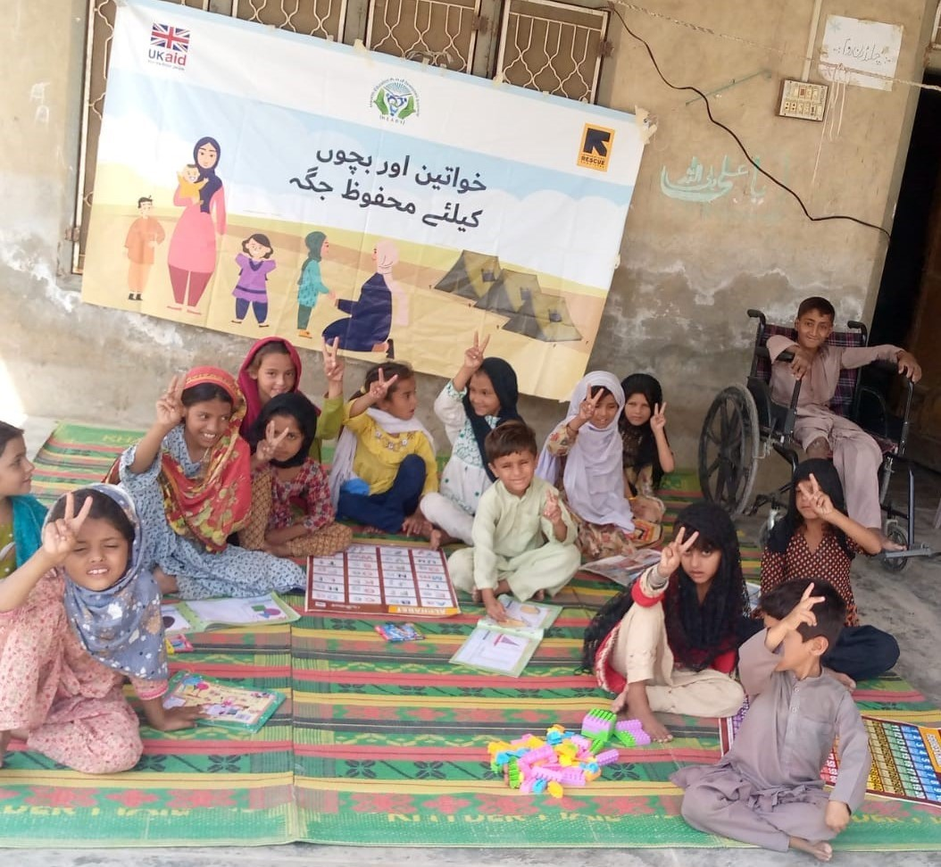
Medical Camp (DI-Khan) | Child- Friendly Spaces

