Project Title: | ACCESS TO CLEAN ENERGY PROJECT (ACEP) - Construction of Mini / Micro Hydropower Projects
Donor: | JV with Telcon Engineering PVT LTD
Duration: | May 17, 2022 to Feb 2026
Working Area: | District Charsadda, Mardan, Bunir, Swat and Haripur of KPK
Beneficiaries: | Selected population of the Districts
Budget: | 40,534,559 (PKR)
Project Objectives: | - To ensure active participation and involvement of the local community in the planning, construction, and operation of the of Mini/Micro Hydropower Plants Projects (MMHPPs) under Access to Clean Energy Program (ACEP).  - To enhance the skills of the local community, particularly women and marginalized groups on entrepreneurship development and capacity-building initiatives to empower women and enhance their employability in the project.  - To promote socio-economic well-being and empowerment of women within the local community by providing microcredit facilities, supporting income-generating activities, promoting women-led cooperatives, and facilitating access to essential services such as healthcare, education, and clean energy.  - To integrate gender mainstreaming principles and practices into all aspects of the MMHPP project, from the initial design phase to the operational stage.
Key Activities: | - Formation of Community Organizations (COs)  - Capacity Building of COs  - Site selection for community schemes  - Environmental assessment of the schemes  - Physical construction of community schemes  - Provision of vocational trainings  - Enterprise development  - Repair and maintenance of the schemes

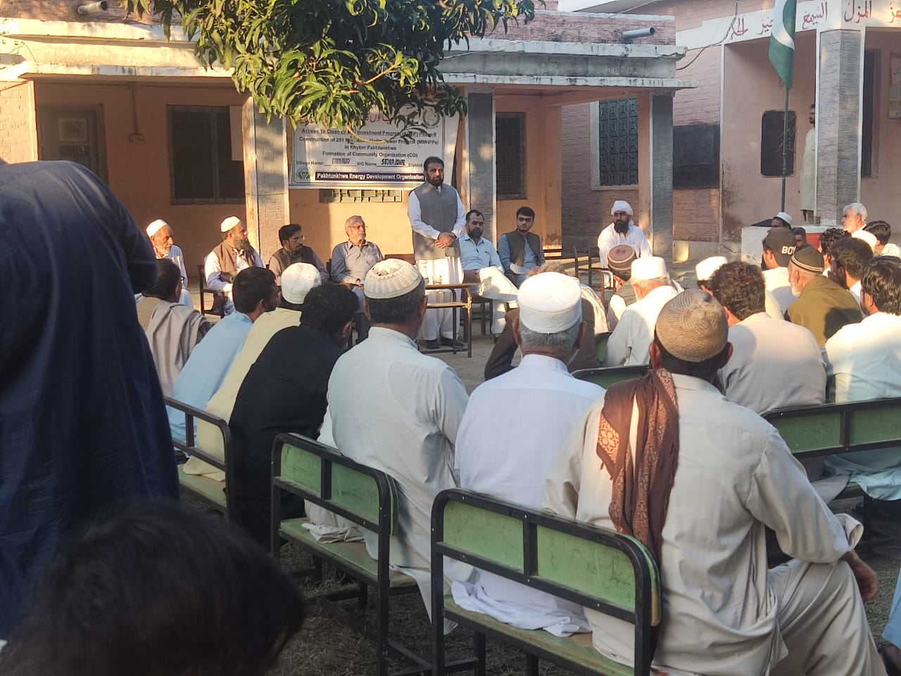 | 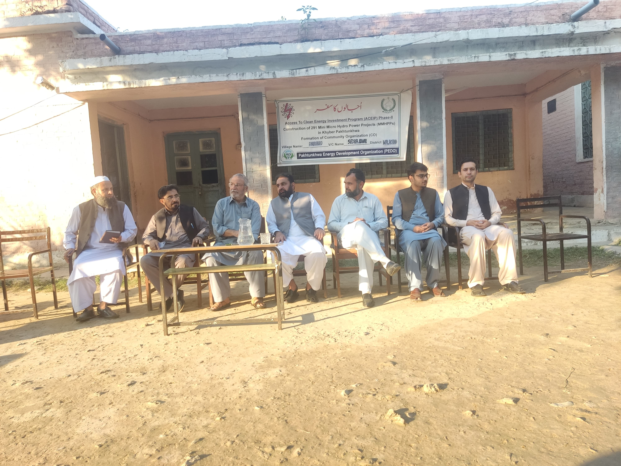
BBCM IN DISTRICT CHAARSADDA | BBCM IN DISTRICT MARDAN

