Annual Report-2024
HEALTH EDUCATION and DEVELOPMENT SOCIETY (HEADS) www.heads-ngo.org

Table of contents
- Executive Summary---------------------------------------------------------------------------------------------------------------------------------2
- Executive Director’s Message--------------------------------------------------------------------------------------------------------------------3

- About HEADS-----------------------------------------------------------------------------------------------------------------------------------------4
- Our Values---------------------------------------------------------------------------------------------------------------------------------------------5
- Organization Structure and Institutional Strength-------------------------------------------------------------------------------------------6
- HEADS Organogram---------------------------------------------------------------------------------------------------------------------------------7
- Geographical Coverage-----------------------------------------------------------------------------------------------------------------------------8
- Thematic Domains-----------------------------------------------------------------------------------------------------------------------------------9
- Our Programme Interventions-------------------------------------------------------------------------------------------------------------------10
- Enhancing District Level Emergency Response Capabilities under Hum Ahang Programme - Disaster Preparedness-----11
- Building Climate Resilience through Rehabilitation/Reconstruction of Green Infrastructure in Flood-Affected Areas----12
- Women Skills Development Center-------------------------------------------------------------------------------------------------------------14
- Establishment of GYNE Section/General OPD------------------------------------------------------------------------------------------------15
- Disaster Emergency Committee Phase-2------------------------------------------------------------------------------------------------------16
- Access to Clean Energy Project-------------------------------------------------------------------------------------------------------------------23
- Our Partners in 2024--------------------------------------------------------------------------------------------------------------------------------24

The Health Education and Development Society (HEADS) is a non-profit, non-governmental organization dedicated to promoting sustainable development and improving the lives of underserved communities. Established in 2013 and headquartered in Peshawar Khyber Pakhtunkhwa, Pakistan, HEADS works in collaboration with government bodies, international organizations, UN agencies and corporate sectors to address humanitarian crises, strengthen community resilience, and advance sustainable development initiatives. Guided by principles of neutrality, impartiality, inclusivity, and accountability, HEADS focuses on areas such as health, education, disaster response, livelihood, WASH, protection and women's empowerment, striving to create a peaceful and inclusive society where everyone can realize their full potential.
In 2024, HEADS achieved significant progress through key initiatives included the Enhancing District Level Emergency Response Capabilities under Hum Ahang Programme, which trained 80 government officials in disaster preparedness, and the Pakistan Flood Response – Disaster Emergency Committee (DEC) Phase-2, which provided emergency support to 778,284 flood-affected individuals through livelihood grants, health services, and infrastructure restoration.
HEADS also worked on Building Climate Resilience Through Rehabilitation/Reconstruction of Green Infrastructure in flood-affected areas, restoring community infrastructure and providing health services to 964 individuals. The Access to Clean Energy Project aimed to bring sustainable energy by constructing mini/micro hydropower projects. In healthcare, the Establishment of GYNE Section/General OPD in Nowshera offered free medical services to over 60,000 beneficiaries, focusing on women's health.
For women's empowerment, the Women Skill Development Center (WSDC) trained 100 girls in stitching and embroidery, helping them gain economic independence. HEADS also promoted protection and gender inclusion by maintaining safe spaces for women and children, distributing dignity kits, and conducting life skills training. Additionally, WASH initiatives improved water access and hygiene practices for thousands in flood-affected areas.
Overall, HEADS' efforts in 2024 demonstrated its commitment to creating a more inclusive and resilient society, empowering vulnerable communities through sustainable development and humanitarian support. For more details, visit www.heads-ngo.org.

EXECUTIVE SUMMARY
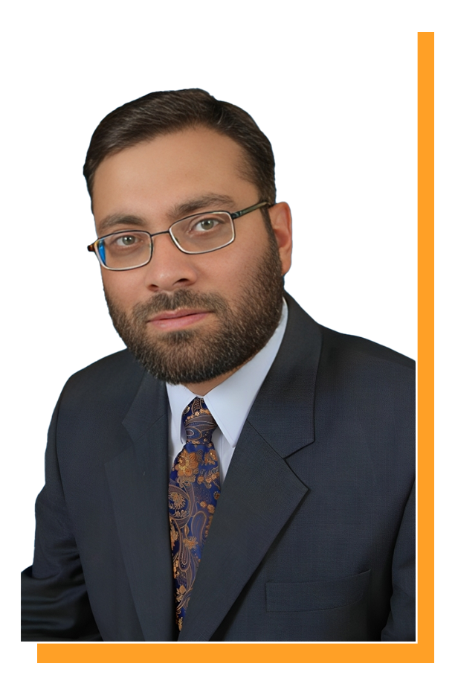
Greetings,
I am honored to be leading Health Education and Development Society (HEADS) as we strive towards our vision of equality for everyone. We at HEADS firmly believe that everyone deserves an opportunity to fulfil their potential for sustainable development. Our mission is to provide a peaceful environment where human beings can thrive.
Through our work in supporting replicable models for sustainable human resource development and collaborating with government/non-government departments, national & international organizations and UN agencies, we have made significant strides in empowering the destitute, poor, and oppressed. We have also made significant progress in advancing sustainable community-based development initiatives in areas such as education, agriculture, health & nutrition, WASH, Protection, livelihood and disaster management.
I am inspired every day by the tireless work of our staff, volunteers, and partners who share our vision and commitment to creating a more equal and just society. Together, we will continue to work towards our goal of achieving sustainable development for all.
Sincerely,
Raza Ullah Jan.
Executive Director,
Health Education and Development Society (HEADS).
EXECUTIVE DIRECTOR’s MESSAGE
Our Vision:
"Every individual, regardless of background or circumstance, enjoys equal opportunities and rights with dignity."

Health Education and Development Society (HEADS) is a non-political, non-profit, and non-governmental organization dedicated to promoting sustainable development and improving the lives of underserved communities. Established in 2013 and headquartered in Khyber Pakhtunkhwa, Pakistan, HEADS is registered under the Societies Registration Act of 1860. In June 2023, HEADS expanded its reach and was officially registered with the Ministry of Economy, Islamic Emirate of Afghanistan, under Registration No. 511.
HEADS envisions a peaceful, inclusive society where everyone can realize their full potential. Collaborating with UN agencies, international organizations, government bodies, and corporate partners, the organization works to address humanitarian crises, strengthen community resilience, and sustain development initiatives.
Guided by the principles of neutrality, impartiality, inclusion, participation, and accountability, HEADS empowers communities through social mobilization while safeguarding the well-being of program participants, staff, volunteers, beneficiaries, stakeholders, and downstream partners.
For a comprehensive profile and to learn more about our work, please visit: www.heads-ngo.org
ABOUT HEADS
Contact Us
Email: info@heads-ngo.org
Website: www.heads-ngo.org
Facebook: https://www.facebook.com/HEADS.official.org?mibextid=9R9pXO

Our Country Offices
Pakistan
House # 219, street # 01, sector # F-9, phase-6, Hayatabad, Peshawar, Khyber Pakhtunkhwa, Pakistan.
Contact # +91 5861889
Afghanistan
Address: House # 34, Street #02, Ansari Square, PD 04, Kabul, Afghanistan
Our Mission:
"Empowering communities through strategic investment in human capital and institutional capacity development, raising sustainable development at the grassroots level."

OUR CORE VALUES
- Transparency and Accountability
Ensuring transparency in operations and accountability to stakeholders.
- Inclusivity and Equality
Promoting equality and inclusivity across all aspects of our work.
- Empowerment
Enabling individuals and communities with skills and resources for development.
- Neutrality and Impartiality
Acting solely on humanitarian principles without bias or favoritism.
- Collaboration and Partnership
Building strong alliances with communities, institutions, and organizations.
- Innovation and Sustainability
Adopting innovative and sustainable approaches to challenges.
- Respect for Human Dignity
Upholding the dignity and rights of every individual we serve.
- Continuous Improvement
Embracing learning and adaptation to enhance impact.

OUR CORE VALUES

Organizational Structure and Institutional Strengths

Governance and Leadership
HEADS operates under an independent Board of Governors (BoG) consisting of seven members, led by the Chairperson. The BoG ensures strategic direction, governance, and policy compliance, maintaining transparency, accountability, and adherence to ethical standards. Its responsibilities include financial sustainability, resource allocation, and recruitment of key personnel. An independent audit committee reporting directly to the Chairperson enhances financial oversight and accountability.

Executive and Management Structure
The Executive Director (ED) oversees daily operations and program implementation, supported by a Management Core Team comprising the Director of Programs, Director of Operations, and departmental heads, including HR, Finance, MEAL, and IT. These departments ensure internal controls, operational efficiency, and compliance with policies and donor requirements.

Field and Regional Presence
HEADS maintains regional offices in Dera Ismail Khan and Swat, with satellite offices in Chitral, Quetta, and Karachi. Field operations are coordinated through project offices led by Project Managers and field teams. Current projects span districts such as Charsadda, Mardan, Haripur, Buner, Nowshera, Dera Ismail Khan, and Upper Chitral.

Institutional Strengths
HEADS’ robust systems for financial, social, and procurement audits uphold compliance and accountability. This strong organizational framework enables effective program delivery, strategic decision-making, and seamless coordination with stakeholders.

Monitoring, Evaluation, and Learning (MEAL) System
The MEAL system at HEADS provides a structured framework to assess and enhance program impact. It integrates data collection, analysis, feedback mechanisms, and knowledge-sharing to evaluate effectiveness and efficiency. This system supports evidence-based decisions, fosters learning, and encourages the adoption of best practices. By embedding monitoring, evaluation, and learning into operations, HEADS improves accountability, demonstrates impact to stakeholders, and optimizes program outcomes.

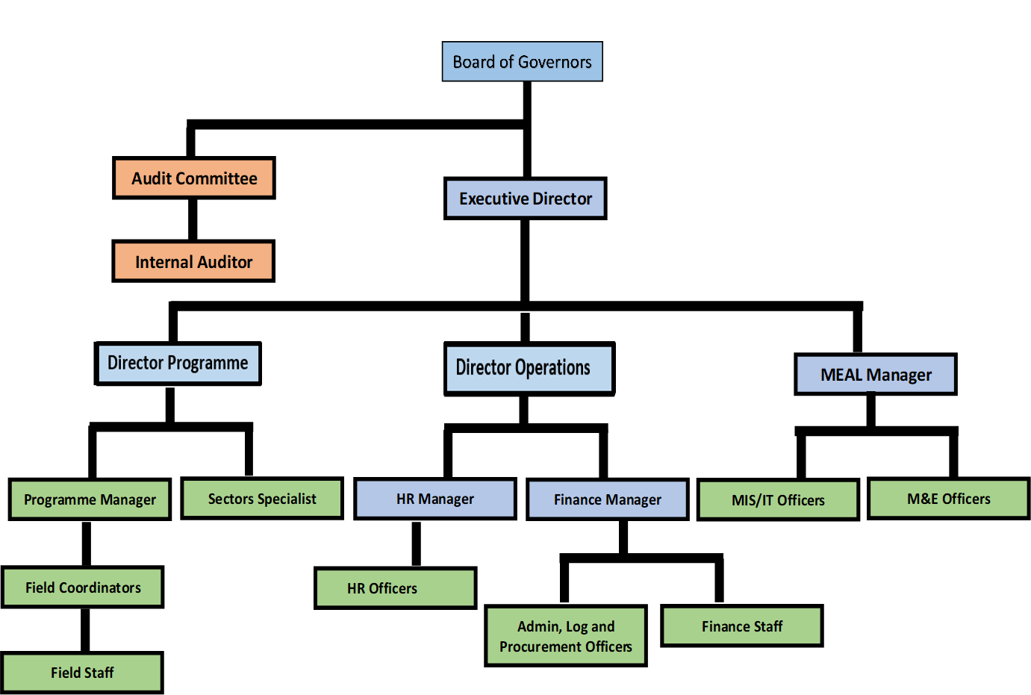
HEADS Organogram

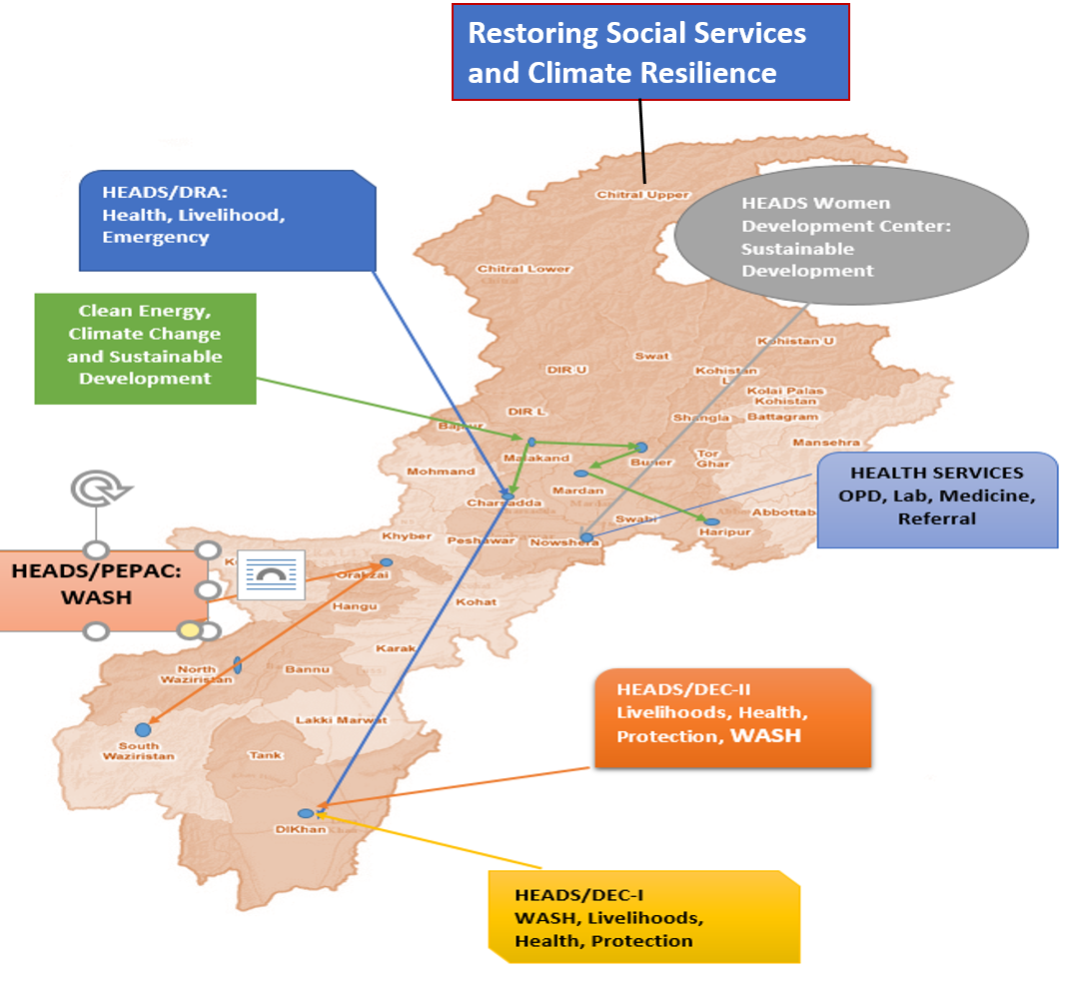
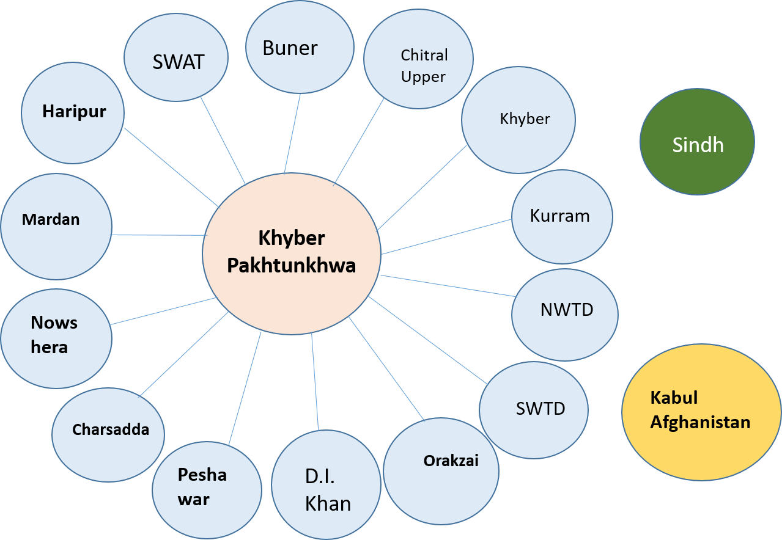
Geographical Coverage

S. No. | Program | Sectors of Interventions
1 | Emergency Response | Food Security, Livelihood, WASH, Community Infrastructure, Shelter, NFI, Nutrition, Education, Health (COVID-19) and Protection.
2 | Sustainable Development | Sustainable Livelihoods, Social Mobilization, Human and Institutional Development, Community Infrastructure, Health, Education.
3 | Research, awareness and Capacity Building | Research, Gender issues, Legal Counselling, referral Mechanism, Social Accountability, Right to Information, Governance.

THEMATIC DOMAIN
OUR Programme interventions

HEADS Sector-wise Experience in Pakistan
Health Education and Development Society (HEADS) is actively engaged in various humanitarian and community development projects across Pakistan. HEADS' projects employ a dual approach: during humanitarian crises, the organization integrates interventions across multiple sectors, whereas community development focuses on a single sector. Currently, HEADS is providing humanitarian assistance to flood-affected populations in Khyber Pakhtunkhwa province. It also operates a health facility in district Nowshera under the Corporate Social Responsibility (CSR) program, funded by Cherat Cement Factory. The key sectors covered in HEADS' integrated humanitarian response include Food Security & Livelihoods, Health, WASH (Water, Sanitation, and Hygiene), Protection, and Restoration of Social Services.
Additionally, HEADS is coordinating with various government and humanitarian agencies in Afghanistan to plan and deliver necessary interventions.
Our Implemented Projects in 2024
HEADS has implemented a total of 22 projects worth PKR 38,699,289 since its establishment, benefiting over 1.4 million people. In 2024, the completed and ongoing projects are as follows:
- Enhancing District Level Emergency Response Capabilities under Hum Ahang Programme
- Women Development Center.
- Establishment of GYNE Section/General OPD.
- Building Climate Resilience Through Rehabilitation / Reconstruction of Green Infrastructure -
- Pakistan Flood Response (DEC Phase-2) -
- ACCESS TO CLEAN ENERGY PROJECT (Construction of Mini/Micro Hydropower Projects
Further insights are provided in this report…
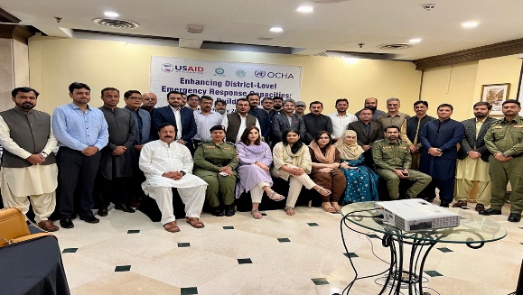
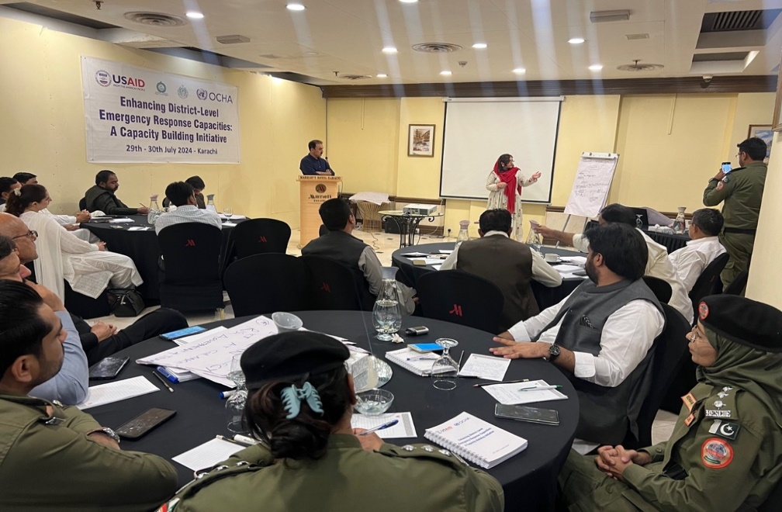
Workshops conducted:
Karachi: 32 government officials from PDMA Sindh and various line departments.
Sukkur: 20 government officials from DDMUs and relevant line departments.

Geographical Area: Karachi, Sukkur- Sindh Pakistan
Project Partner/collaborator: Center for Peace and Development Initiative (CPDI)-USAID
Start and End Date: July, 2024 to Sep, 2024
Total Budget: PKR: 6,497,792
Participants: 80
Breakdown of Stakeholders/Participants
Stakeholders/  Participants | Men | Women | Total
Civil Society Organizations | 7 | 6 | 13
Government officials of  PDMA & DDMUs | 43 | 9 | 52
Other (UN Agencies) | 7 | 2 | 9
CPDI/HumAhang/HEADS  Staff | 5 | 1 | 6
Grand Total | 62 | 18 | 80
Aim and Objectives: The activity aimed to build the capacity of PDMA and DDMA members in Disaster Risk Reduction (DRR) and Management (DRM), helping them develop district-level plans. Trainings were held in Karachi and Sukkur, with representation from all Sindh districts. HEADS Pakistan implemented the program, while UNOCHA facilitated the sessions.
Key Achievements: A total of 80 participants, including 52 government officials, were trained through two days training sessions on disaster risk and preparedness. The trainings were conducted in Karachi and Sukkur.

ENHANCING DISTRICT LEVEL EMERGENCY RESPONSE CAPABILITIES UNDER HUM AHANG PROGRAMME
Disaster PREPAREDNESS (RESPONSE & Recovery)

HEADS, in collaboration with Sindh PDMA and supported by HumAhang and UNOCHA, conducted two days training session on Disaster Risk Reduction (DRR) and Disaster Risk Management (DRM) in Karachi and Sukkur. Stakeholders included Civil Society Organizations, government officials from PDMA and DDMUs, UN agencies, and CPDI/HumAhang/HEADS staff, with participants from all districts of Sindh. The sessions focused on enhancing participants' skills in disaster preparedness, community-based risk management, and policy implementation. These workshops empowered stakeholders to develop and implement DRR and DRM plans effectively. HEADS Pakistan managed the logistical and operational aspects of the activity.
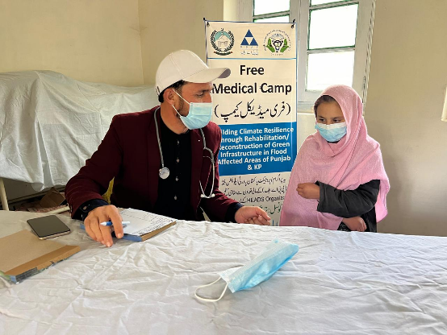
Health Education and Development Society (HEADS), funded by Pakistan Poverty Alleviation Fund (PPAF), is implementing a project to restore social services and build climate resilience in the flood-affected areas of Khot and Terich Union Councils, Upper Chitral. A Rapid Need Assessment (RNA) was conducted in 15 revenue villages to gather disaster-related information. Key Informant Interviews were held with seven line departments in collaboration with HUJRA VSO. Community Resource Persons (CRPs) were trained in social mobilization, health, education, CBDRM, and GBV and formed 58 Community Organizations, clustered into 11 Village Organizations, which created 11 Village Development Plans. Eight free medical camps provided health services to 964 individuals, including 668 women and 296 men.
Key Components
- Restoration of Social Services
- Climate Resilient Crucial Community Infrastructure
- Climate Resilient Livelihood Practices (Food Security & Income Generation)
- Climate Resilient Preparedness & Capacity Building
Geographical Area (District/Union Councils):
Upper Chitral, Khot & Terich

Project Partner/collaborator: Pakistan Poverty Alleviation Fund (PPAF).

Start and End Date: May 2024 to April 2026

Total Budget: PKR: 72’944’500

Planned Beneficiaries (May 2024-April 2026): 9540 (Men-5056, Women-4484)
Reached (May- Dec 2024): 2,555.
(Men-764, Women- 1,391. Unspecified-400)

Key Achievements
1. Organized 8 medical camps, with four camps in each of the flood-affected remote areas of UC Khot and Terich, Upper Chitral. These camps provided free health checkups, medicines, and vaccinations, benefiting 964 individuals, including 668 women, 296 men and 194 children

Building Climate Resilience through Rehabilitation/ Reconstruction of Green Infrastructure in Flood Affected Areas of Punjab and Khyber-Pakhtunkhwa
Multi Sectors INTEGRATED Interventions

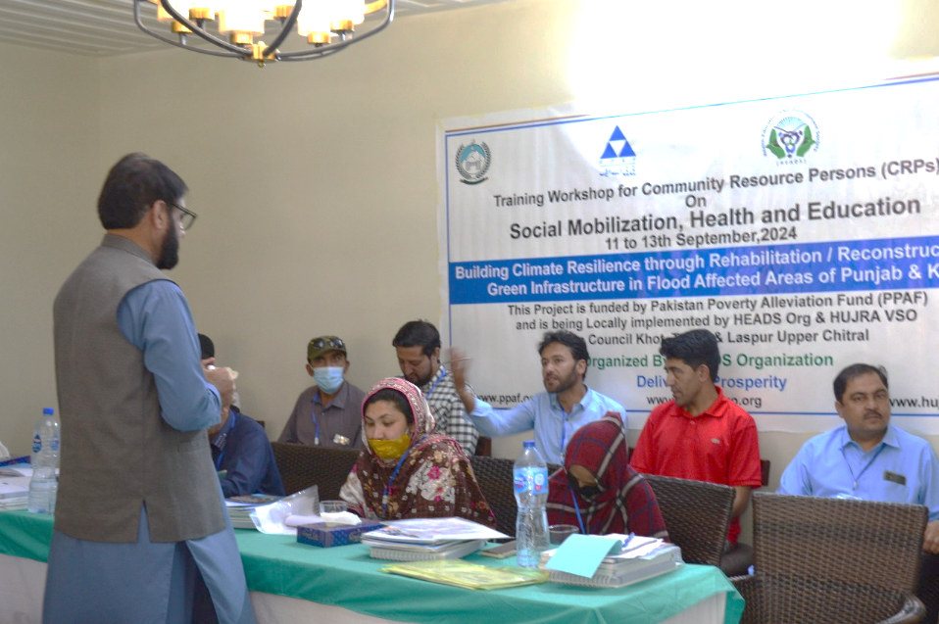
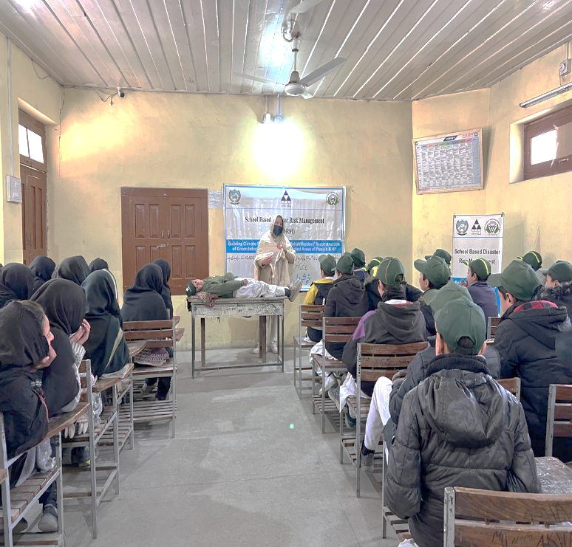
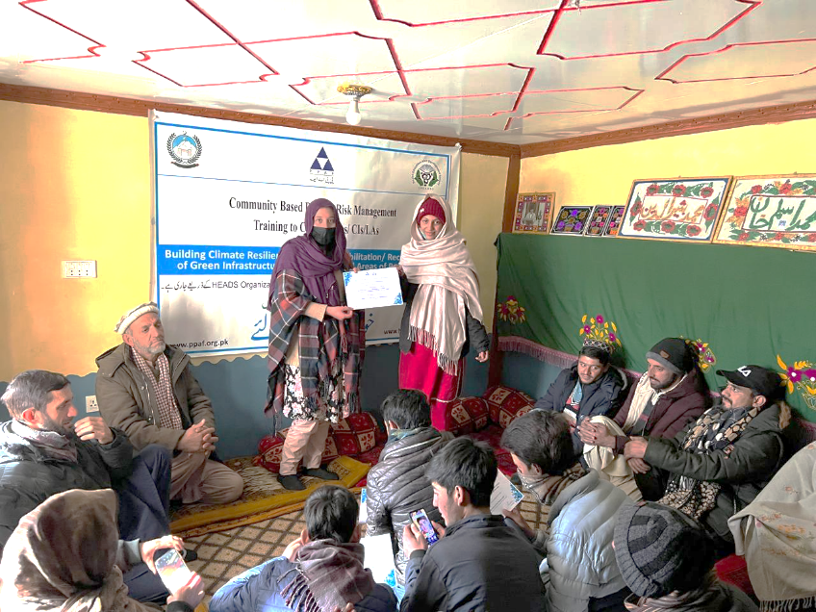
Key Achievements:
2. Organized two mega events: Youth Day (65 participants in Terich) and Independence Day (400 participants in Khot).
3. Trained 10 Community Resource Persons (CRPs) in mobilization, health, GBV, disaster preparedness, and education.
4. Formed 58 Community Organizations (COs) and 11 Village Organizations (VOs), creating 11 Village Development Plans (VDPs).
5. Conducted 20 GBV sessions (498 participants: 314 women, 184 men)
6. Organized 8 Community Based Disaster Risk Management CBDRM sessions (222 participants: 132 women, 90 men).
7. Held 23 SBDRM sessions in schools, engaging 731 students, teachers (302 males, 429 Female).
8. Conducted 8 Social Mobilization Trainings

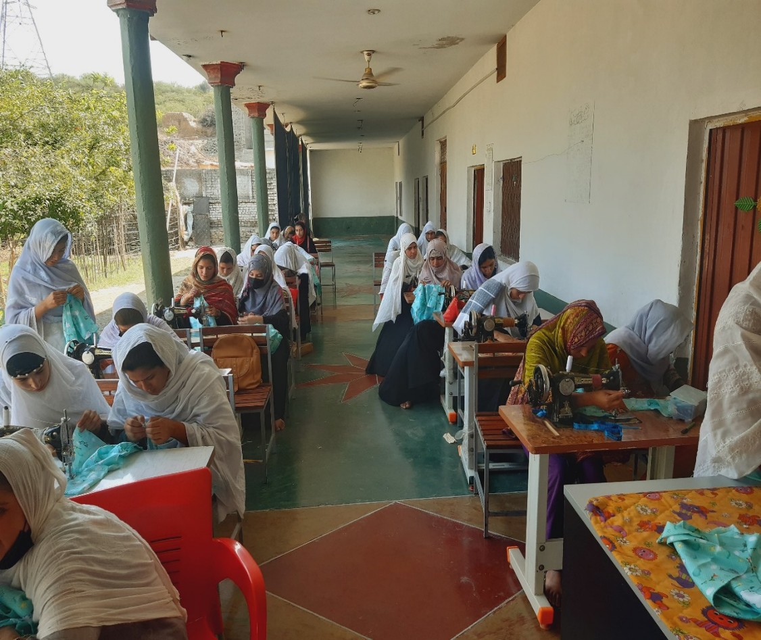
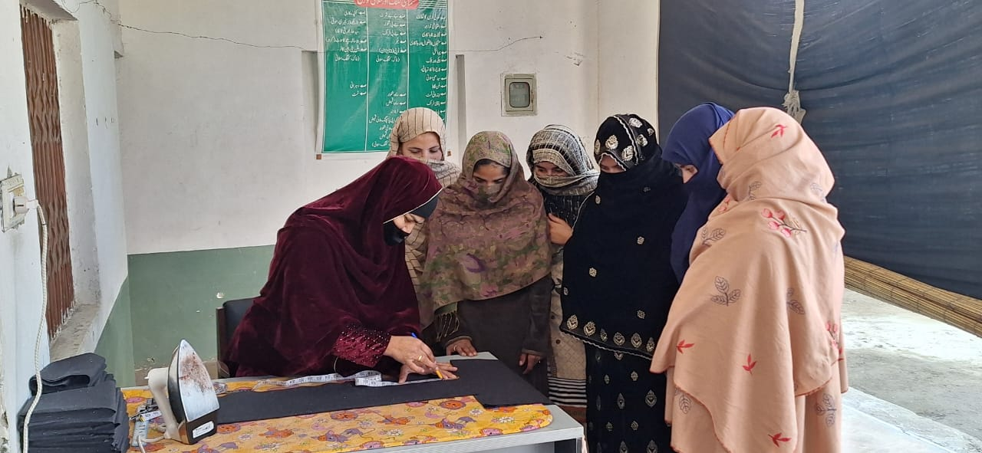
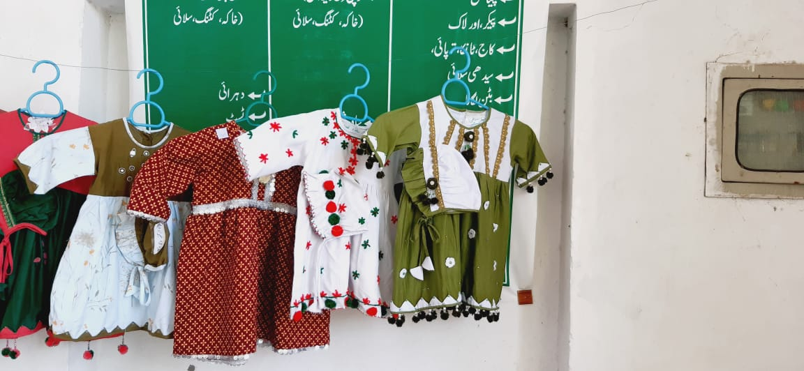
Geographical Area (District):
Cherat - Nowshera
Partner/collaborator: Cherat Cement company Limited (CCCL)
Start and End Date: Oct, 2024 to Sep, 2025
Total Budget: PKR: 2,994,600
Beneficiaries: 150 (Girls & Women)
The WDC project, continuing from its previous phase, runs from September 2023 to September 2024 and is funded by Cherat Cement Company Limited (CCCL) under its Corporate Social Responsibility (CSR) initiative. In September 2023, CCCL provided a grant of PKR 2,816,000 to HEADS to establish and operate the Women Development Center (WDC) for 12 months.
In the first phase, 100 women were trained in stitching and embroidery. Building on this success, the current phase is empowering 150 girls with these essential skills. In December 2024, HEADS achieved a significant milestone by registering WDC Cherat with the Khyber Pakhtunkhwa Testing Trade Board, ensuring certification and enhancing the program’s impact.
Key Achievements of WDC (2024):

1.Trained 100 female in stitching and embroidery during the first phase.
2.Enrolled 100 girls to equip with stitching and embroidery skills in the ongoing phase.
3.Successfully registered WDC Cherat with the Khyber Pakhtunkhwa Trade Testing Board, ensuring formal certification for trainees.
Women Development Center (WDC)

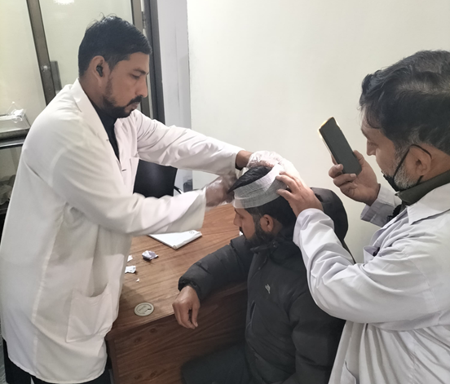
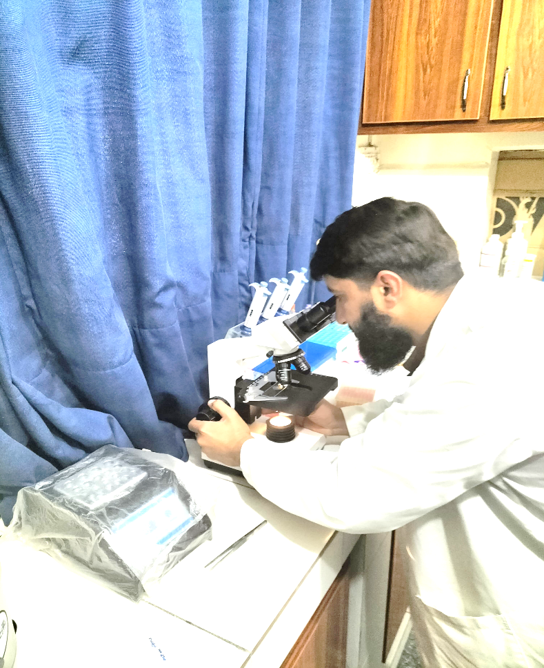
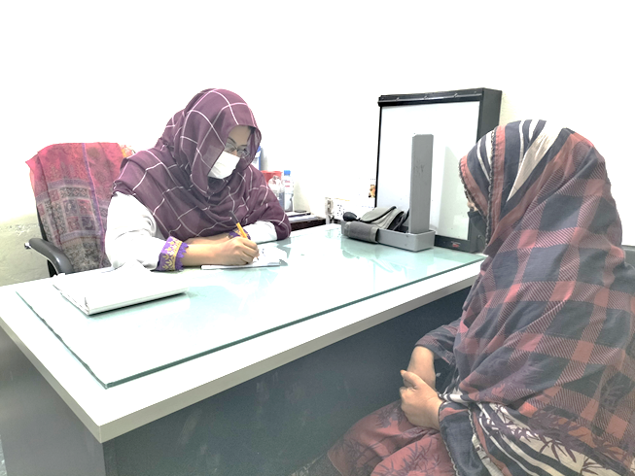
Establishment of GYNE Section/ General OPD
Health Care Services
Geographical Area (District):
Cherat - Nowshera
Partner/collaborator: Cherat Cement company Limited (CCCL)
Start and End Date: Oct, 2024 to Sep, 2025
Total Budget: PKR: 11,635,542
Reached Beneficiaries: 60,222
The project marks the continuation of the collaboration between HEADS and Cherat Cement Company Limited (CCCL). Initially launched in September 2023 with a grant of PKR 10,974,996, the project aimed to provide Primary Healthcare (PHC), focusing on gynecological services for women in underserved areas of Cherat, Nowshera. A Free Medical Dispensary was established to deliver these services.
After the project's successful completion in September 2024, CCCL extended additional funding to sustain the services for another year, now running until September 2025.
Free services offered under the project include:
Medical consultations and medication
Routine lab investigations, Ultrasound services

Key Achievements (2024)
General OPD | Male | Female | Boys | Girls | Total
 | 8445 | 15050 | 17174 | 19553 | 60,222
Percentage | 14% | 25% | 29% | 33% | 100
Lab. Test |  | 3247 | Ultrasound |  | 1441

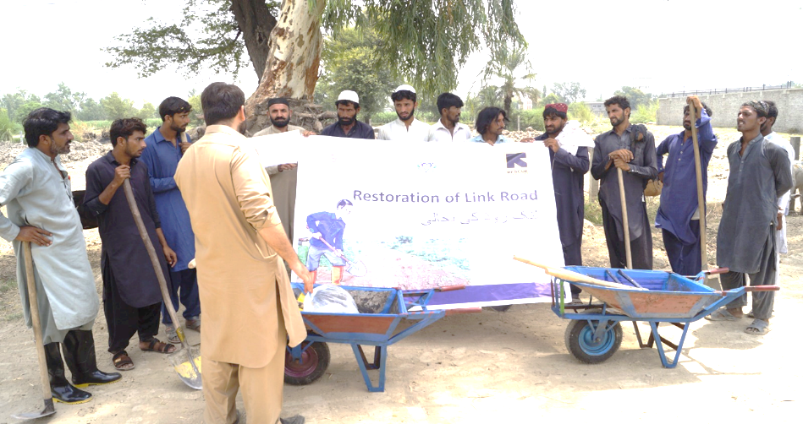
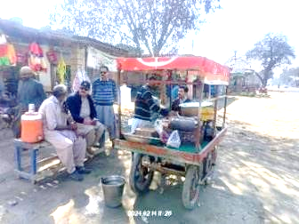
Geographical Arear: Dera Ismail Khan (DI Khan) KP
Partner/collaborator: International Rescue Committee (IRC)
Start and End Date: March 2023 to July 2024
Total Budget: PKR: 780,40,550
Beneficiaries: 778,284
The DEC project continued HEADS' efforts with IRC to respond to the 2022 Pakistan floods, starting in October 2022 with a budget of PKR 9,551,475 and concluding in February 2023. Due to its positive impact, IRC extended the project with an additional grant of PKR 78,040,550, and all activities were successfully completed by July 2024, meeting all targets, goals and objectives.
Key Sectors Covered under the Project: LIVELIHOOD, HEALTH, PROTECTION. WASH
Key Achievements (2024)

Agriculture Inputs: HEADS, in partnership with the Agriculture Extension Department, trained 183 flood-affected clients in kitchen gardening, with 126 males and 57 females participating. Each participant received a toolkit and seeds to help them start their own gardens, fostering sustainable food production in the region.
Enterprise Development Grants: A total of PKR 21,650,000 was allocated to provide PKR 50,000 grants to 433 flood-affected individuals, including 226 males and 207 females. The grants supported small business recovery, with additional training and business planning, prioritizing vulnerable female-headed households and families with orphans or unaccompanied children.
Cash for Work: The Cash for Work program successfully implemented 41 schemes to restore 11 link roads, 10 drainage systems, and 10 irrigation channels, with additional drain desilting at 10 locations. These projects created employment opportunities, benefiting 275,496 people through infrastructure improvements and cash support.
Livestock Vaccination: In collaboration with the Livestock & Dairy Development Department, HEADS conducted vaccination and deworming campaigns in flood-affected villages, reaching 2,200 households. A total of 7,278 large animals and 1,100 small animals were vaccinated, and 1,020 ruminants received deworming treatments, ensuring the health of livestock in the area.

- Livelihood

Disaster Emergency Committee Phase-2
Integrated Multi sector Emergency RESPONSE AND Recovery Project
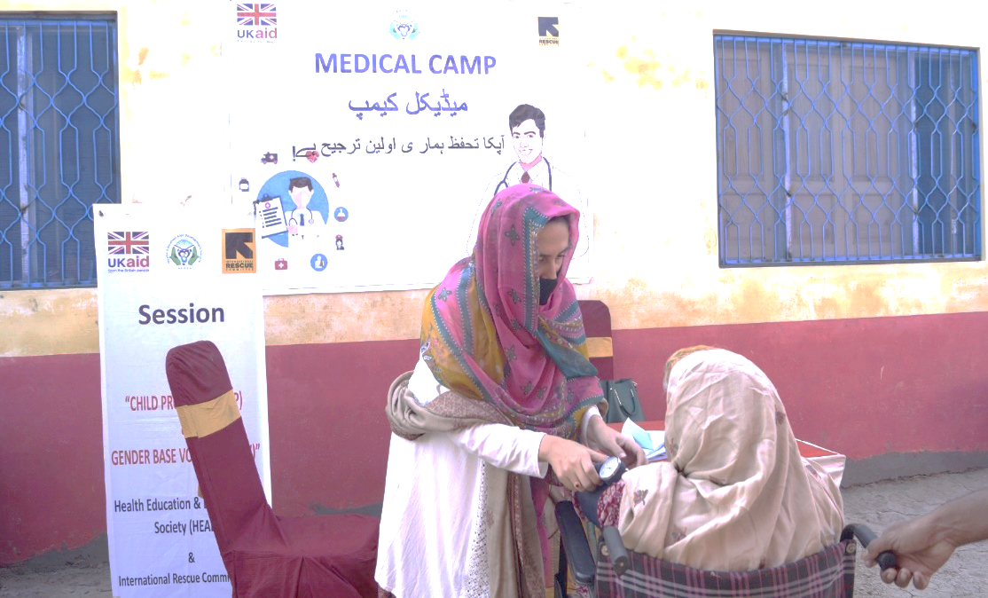
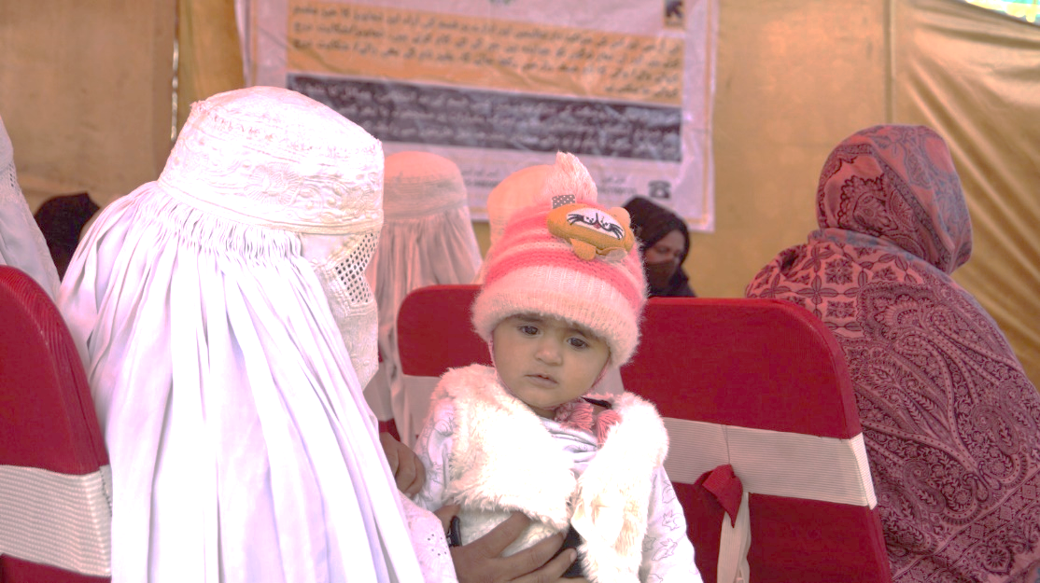
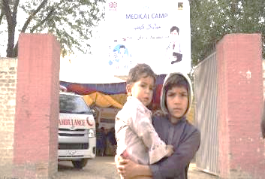
2. Health
A. Primary Healthcare Service Provision: HEADS, in coordination with the District Health Department, set up 12 medical camps in flood-affected villages of Dera Ismail Khan. These camps provided healthcare services, including antenatal care, postnatal care, and referrals, benefiting 4,799 individuals, including both host communities and Afghan refugees. Rapid diagnostic kits were used to detect diseases like malaria and dengue.

B. Facility Rehabilitations: HEADS rehabilitated six health facilities, including three Basic Health Units (BHUs) and three BemOC centers, in flood-hit areas. Upgrades included solar inverters, placenta pits, and essential medical supplies, benefiting 28,141 patients. Training sessions on infection prevention and emergency services were conducted for 47 health workers.

C. Nutrition Services: HEADS deployed trained nutrition staff to three health facilities and conducted 1,072 MUAC assessments, identifying and referring malnutrition cases. Outreach sessions on health, hygiene, and nutrition reached 10,082 participants, including pregnant and lactating women, while Nutrition Assistants screened 8,569 clients, addressing malnutrition.
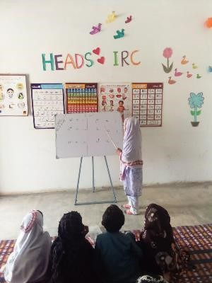
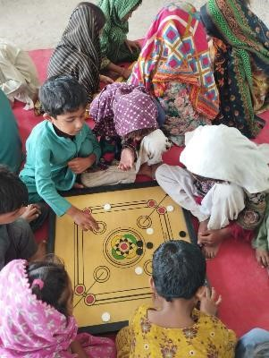
3. Protection
• Establishing/Continuing Women and Child Safe Spaces (WCSSs): Maintained 7 WCSSs post-project closure, enrolling 1,569 individuals, and trained 350 women in tailoring and embroidery, with additional skills passed to 260 women.
• Child Protection Units and Committees: Formed 12 Child Protection Committees (172 members) and handled 46 child protection and GBV cases. A sub-desk was established at Mufti Mehmood Teaching Hospital DI Khan to assist referred patients.
• Dignity Kits and Solar Lamps Distribution:
Distributed 2050 dignity kits and 966 solar lamps, benefiting approximately 13,625 women, girls, and families in flood-affected areas.
• Safety Audits: Conducted 35 safety audits at WCSSs, identified GBV risks, developed safety action plans, and referred women to health and psychosocial support services.
• Formation and Training of Children’s Clubs: Established 12 children’s clubs with 106 members and 82 facilitators to promote child rights, enhance protection, and build resilience in disaster situations.
• GBV/Referral Mechanism: Trained 146 stakeholders on GBV, child protection, and juvenile justice to strengthen community support and referral systems.
• Life Skill-Based Education (LSBE) Sessions: Conducted 12 LSBE sessions training 276 participants (97 boys, 163 girls, 16 women) in personal safety, decision-making, and conflict resolution skills.

3. Protection
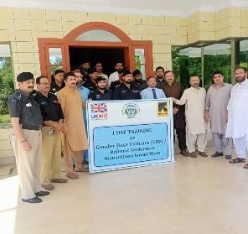
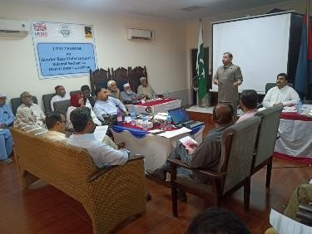
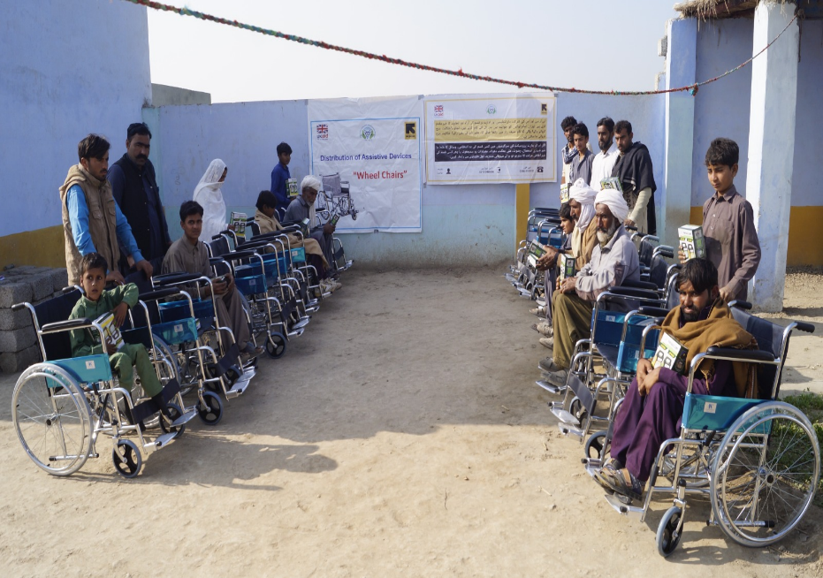
• Assistive Devices for PWDs: Provided 267 PWDs in flood-hit areas with essential items like wheelchairs and solar lamps through community support and MEAL verification.
• Stakeholder Training on CP/GBV: Trained 40 stakeholders, including law enforcement and NGOs, on case management and GBV prevention in two sessions.
• MHPSS Sessions: Held 55 sessions for 1,233 participants on self-esteem, parenting, and stress management.
• Referral Workshops: Organized two workshops for 109 participants to strengthen multi-sector collaboration on referral mechanisms.
• Referral Pathways: Created and shared a referral directory linking stakeholders to key services like healthcare and legal aid.
• Gender Inclusion Workshop: Trained 57 male participants, promoting gender equality and inclusivity among community leaders and activists.
• Opinion Leader Workshop: Engaged 25 community leaders to enhance mobilization, social cohesion, and leadership skills.
• Civil Documentation Support: Processed free civil documents for 1,838 clients, including birth and marriage certificates, with LG&RDD collaboration.
• Community Awareness on CP/GBV: Conducted 601 sessions for 14,195 participants on child protection, GBV, and reproductive health.

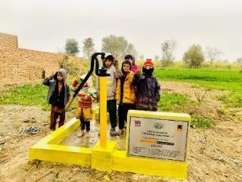
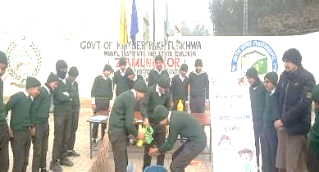
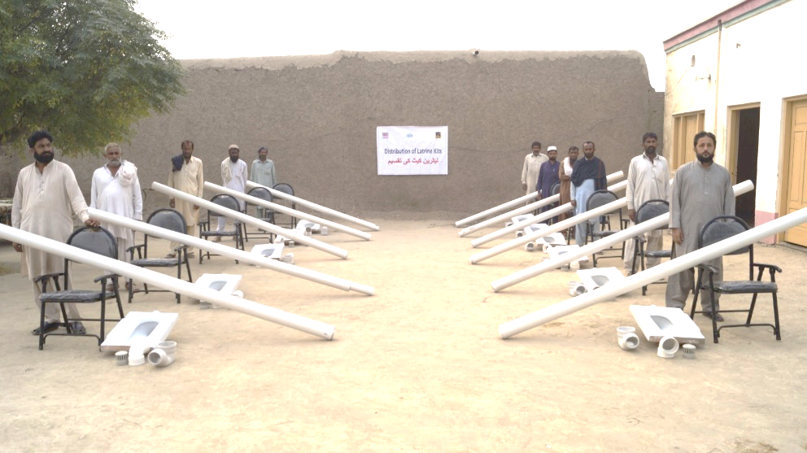
• Inclusive Village Committees: 50 Gender-Segregated Committees with 561 members (297 males, 264 females) were formed to assess needs, support projects, and promote inclusivity.
• Training on PLA & CLTS: 40 committees (772 people) were trained in PLA modules and CLTS to address WASH needs, hygiene, and sanitation improvement.
• Rehabilitating Water Sources: 11 hand pumps (benefiting 1,937) and 7 Water Supply Schemes (benefiting 30,030) were restored with solarized filtration and O&M kits.
• WASH in Health & Schools: Improved WASH facilities in 7 health centers (45,063 beneficiaries) and 5 schools (897 students) in coordination with government departments.
• School WASH Clubs: 8 WASH clubs with 267 members (students and teachers) promoted personal, domestic, and environmental hygiene.
• Hygiene Promotion Sessions: 300 sessions (6,276 participants) addressed hygiene, sanitation, antenatal care, and breastfeeding in flood-affected areas.
• WASH NFI Kits: 2,050 WASH kits were distributed to vulnerable households, benefiting 13,325 individuals, with a focus on female-headed homes.
• Latrine Kits & Cash Incentives: 465 households received latrine kits, and 409 received PKR 12,000 for construction in flood-affected areas.

4. WASH
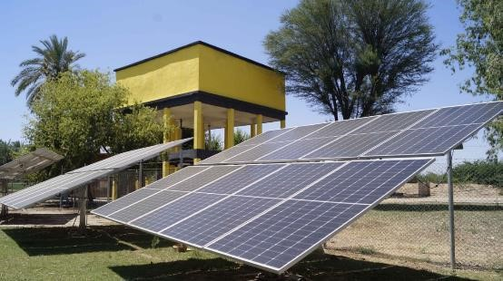
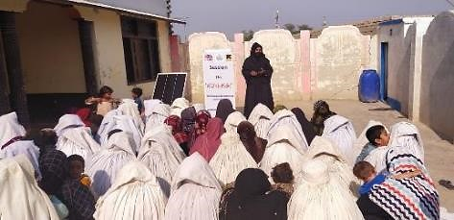
4. WASH
• Menstrual Hygiene Sessions: 40 sessions engaged 949 females, promoting awareness and hygienic menstrual practices among flood-affected women and girls.
• Solid Waste Management: 11 Solid Waste Points were built, benefiting 16,637 individuals, with cleaning campaigns involving schools and community members.
• Vector Control Sprays: Two rounds of sprays in 29 villages (118,363 people) reduced vector borne disease risks and improved public health.

Success Story from DEC-2 D I KHAN
Rebuilding Hope: Sumaira's Journey from Devastation to Renewal in Chah Baili

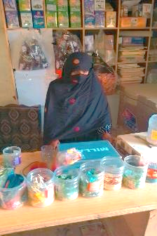
In the vibrant community of Village Chah Baili, where 15,000 residents contribute to the rich tapestry of life, Sumaira stood out as a symbol of resilience. The village, home to 2,440 men, 3,560 women, 4,320 boys, and 4,680 girls, thrived primarily on agriculture, which was the backbone of its economy. Daily wage labor and employment in government and private sectors further diversified the income streams, creating a stable and close-knit community deeply rooted in traditional values.
However, the devastating flood in Tehsil Paroa, District Dera Ismail Khan, shattered this stability. The fertile lands were submerged, crops were destroyed, and the primary source of income for many families was wiped out. The community, which once relied on its established livelihoods, suddenly faced financial strain and uncertainty. The focus shifted from routine occupations to the urgent need for survival and rebuilding.
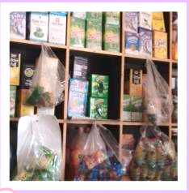
Sumaira's family was among those hardest hits. The floodwaters not only inundated their home and store but also washed away their hopes and dreams. Left homeless and facing starvation, they were in desperate need of assistance. Recognizing Sumaira’s potential to rebuild her life, the International Rescue Committee (IRC) and the Health Education & Development Society (HEADS) intervened. They provided her with a business grant of PKR 25,000, which became a lifeline for her.
"This grant was not just money; it was a ray of sunshine piercing through the storm clouds," Sumaira shared. With this financial assistance, she was able to invest in her store, gradually rebuilding her life and her family's future. Before receiving the grant, her income was modest, but the additional support allowed her to expand her inventory, attract more customers, and earn a reasonable profit. "The increase in profit not only helped me to expand my store but also made my life easier and more relaxed. I am very grateful to both IRC and HEADS," she expressed.
Sumaira’s story is a powerful testament to resilience and the transformative power of timely support. It serves as a reminder that even after the fiercest storms, the sun can shine again, bringing new opportunities and renewed hope. Through the collaborative efforts of IRC and HEADS, Sumaira’s journey from devastation to renewal stands as an inspiring example of how targeted interventions can empower individuals to reclaim their lives and contribute to the recovery of their communities.
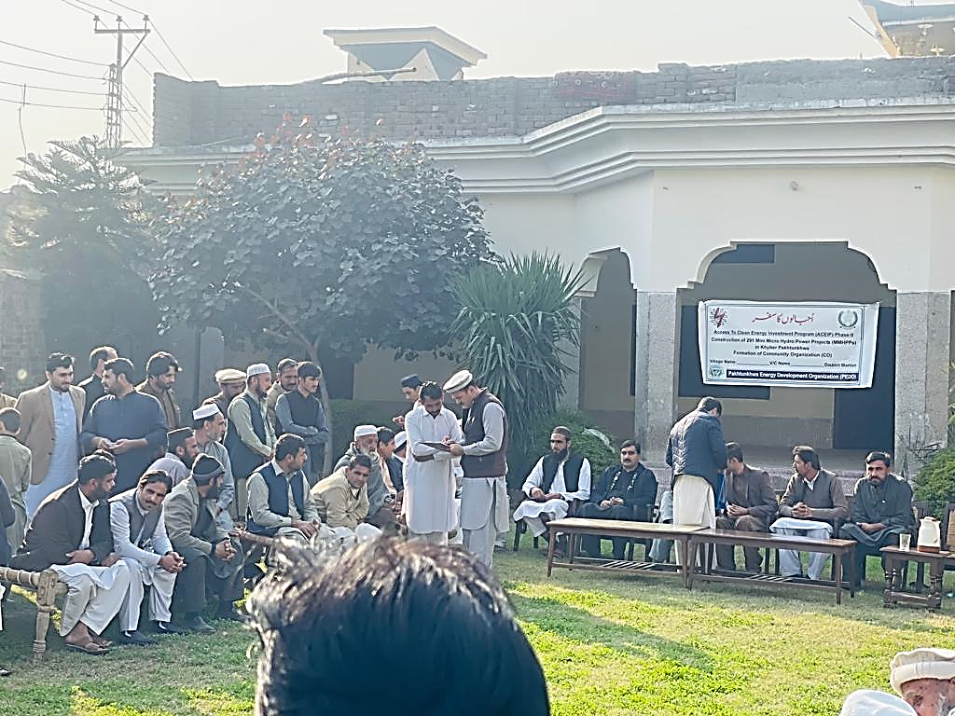
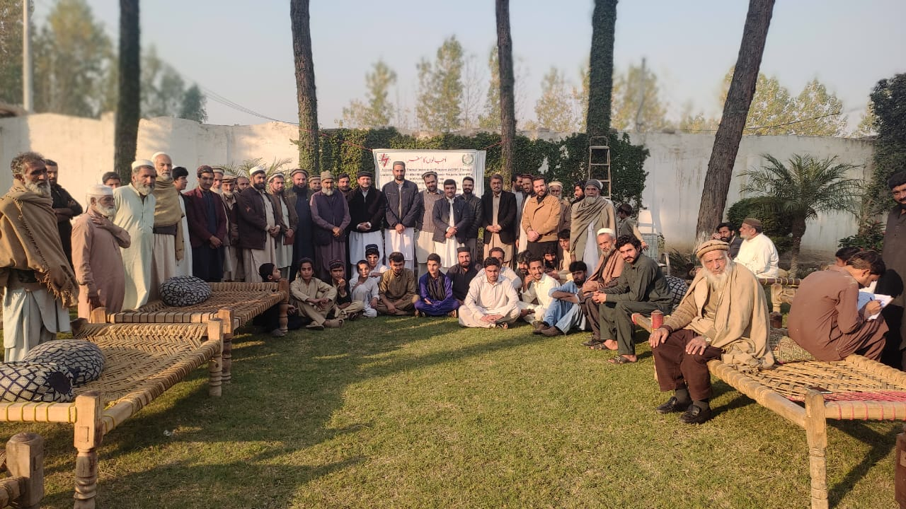
Geographical Area (Districts):
Charsadda, Mardan, Bunir, Swat and Haripur
Partner/collaborator: JV with Telcon Engineering PVT LTD Funded by (PEDO)
Start and End Date: May, 2022 till to 16th Feb, 2026
Total Budget: PKR: 40,534,559
Beneficiaries: 8,600

Key Achievements (2024)
Formation of Community Organizations (COs): 5
Capacity Building of Cos: 5
Site selection for community schemes: 5
Environmental assessment of the schemes: 5
Physical construction of community schemes: 5

The Access to Clean Energy Project is a joint venture between HEADS and Telcon Engineering, initiated in May 2022. Funded by the Pakhtunkhwa Energy Development Organization (PEDO), a government body of Khyber Pakhtunkhwa, the project aims to provide sustainable energy solutions to underserved communities. HEADS is actively building the capacity of the target communities, enabling them to make informed decisions about their development and oversee the project's activities. This initiative reflects HEADS' commitment to empowering communities and promoting sustainable development through clean energy access.

ACCESS TO CLEAN ENERGY PROJECT
(Construction of Mini / Micro Hydropower Projects)

Our Partners in 2024
